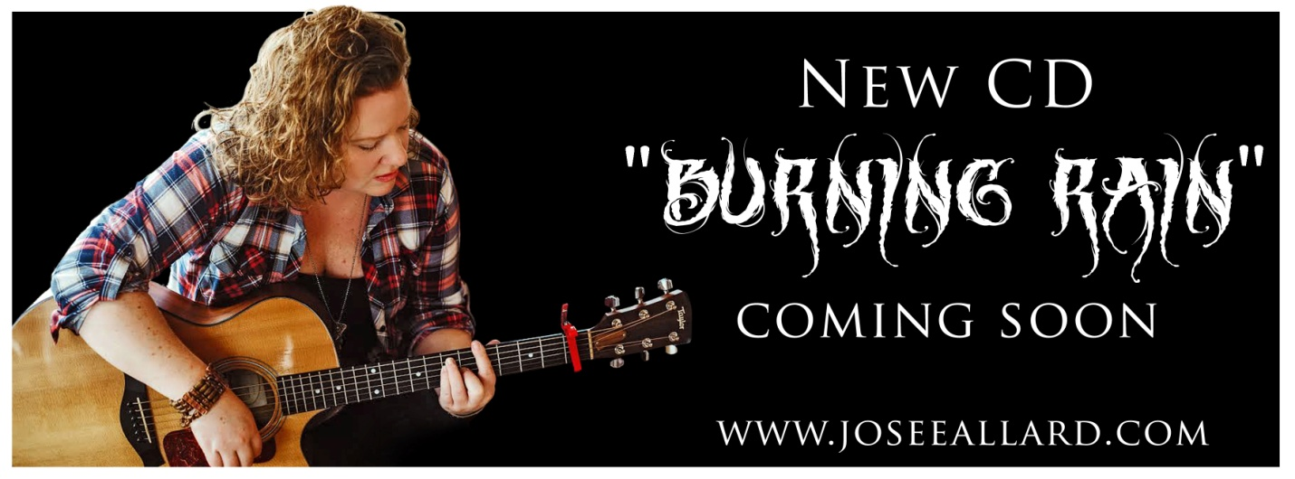
“Burning Rain” Release date: May 11, 2019
First Single: “Burning Rain”

Bio Josee Allard
Josee Allard is a dynamic performer, exuding positive energy and passion at every show she performs. A resident of Merrill, NY in the Adirondack Mountains, she has a natural gift for hooks and melodies and always leaves her audience feeling good and wanting more. Josee has a heartwarming way of relating life experiences through her songwriting, whether it’s falling in love, enjoying a snowy day or supporting a friend through life’s challenges, her guitar, bass or ukulele help her tell the story. And when she breaks out the harmonica, things really start to cook!
Born in British Columbia, Canada, Josee is fluent in both English and French. The Folk-Pop multi-instrumentalist moved to Quebec to be closer to the music scene, captivating both Francophone and Anglo audiences with her powerful performance style and audience interaction. Clever lyrics and song structure, a keen sense of melody, a sixth sense when it comes to a hook and the playing chops to pull it all together make her a popular regional performer, invited back to every venue she plays.
When reflecting on her influences, Josee cites fellow Canadian singer-songwriter Sara McLachlan, the pop-rock-country style of Sheryl Crow, and the folk rock, multi-instrumentalist style of Jack Johnson. Her 2014 album, Day by Day, produced by singer-songwriter Pascal Dufour whom she met in Quebec, was well received by the press, calling Josee “the next female version of Jack Johnson”. Their live performances feed her inspiration.
Dufour is part of Josee’s new dream team of collaborators, with whom she says “the magic and creation instantly took place”. The pair have just finished a new EP, her fifth release, titled Burning Rain, which is slated for release in May of 2019. It features longtime friend and collaborator, Elizabeth Blouin-Brathwaite on percussion, handpicked seasoned musicians from Montreal, Quebec and five original songs written by Josee, which range in style from folk to pop to country.

Allard has opened for some big name acts on the Québec music scene including Jean Leloup, leader of the Francophone pop renaissance, and Diane Dufresne, singer of popular Quebec songs. She represented Francophone Canada at the Vancouver 2010 Winter Olympics. She will be performing songs from the new EP and more with her band, The Josee Allard Trio, which consists of Michael Dufort on percussion and Kevin Glennon on electric guitar.
Michael grew up in Whippleville, NY and has been playing drums for thirty-two years in local bands such as Thirty1&Mandolin, Soulshine, 393 Above and Wizards in Winter. His biggest influences include Pink Floyd, The Shins, Ben Folds, Modest Mouse, and Band of Horses. He lives in Malone, NY with his wife, Erika and their six kids.
Kevin Glennon is renowned as one of the best guitarists in the North Country. He grew up in Brainardsville, NY and started playing guitar when he was nine years old. He made his start playing campsites and teen dances when he was sixteen and has been teaching guitar and music theory for eighteen years. He has played in local bands over the past thirty plus years including The KGB, Paid Company, Missguided &The Boneyard Bluesband.
To find out more visit: www.joseeallard.com
Facebook: https://www.facebook.com/musicJoseeAllard/
Youtube: https://www.youtube.com/channel/UC8x6USNhvMf0HhPiKyAc0ow

